**FPT ACADEMY INTERNATIONAL**



## FPT – APTECH COMPUTER EDUCATION

**AmazingBridges**

|  |  |  |  |
| --- | --- | --- | --- |
| **Center Name** | | FPT – Aptech – HCM2  Address: 590 Cach Mang Thang Tam, District 3, Ho Chi Minh City | |
| **Instructor** |  | Ms. Le Mong Thuy |  |
| **Class** |  | T1.2302.E1 |  |
| **Group** |  | 2 |  |
| **Group members** | | **Name** | **Student ID** |
|  |  | Tran Ngoc Bao Khoa | Student1457503 |
|  |  | Pham Van Phuc Loc | Student1448357 |
|  |  | Do Quang Nhat | Student1457499 |
| **Duration** | Start date | 23rd May 2023 |  |
| End date | 23rd Jun 2023 |  |

**This is to certify that**

**Mr.:**

Tran Ngoc Bao Khoa

Pham Van Phuc Loc

Do Quang Nhat

**has successfully designed & developed**

eProject: AmazingBridges website

**Submitted by:**

Tran Ngoc Bao Khoa

**Date of issue:**

**Authorized Signature:**

**Contents**

FPT-Aptech Computer

Education…………………………………………….………………………………………………………….. 1

Acknowlegment………………………………………………………………………………………………. 4

Synosis…………………………………………………………………………………………………………….. 4

Problem definition…………………………………………………………………………………………. 5

Customer’s Requirements Specifications (CRS)……………………………………………… 6

Scope of the work (IN BRIEF)…………………………………………………………………………. 7

Architeture And Design Of The System…………………………………………………………. 8

Diagram of The Website………………………………………………………………………………… 9

Task Sheet Review 1 ………………………………………………………………………………………10

Site Map………………………………………………………………………………………………………….11

Mock of The Website……………………………………………………………………………………...12

Task Sheet Review 2 ………………………………………………………………………………………18

Website Description……………………………………………………………………………………….19

Javascript Description…………………………………………………………………………………… 24

Task Sheet Review 3 ……………………………………………………………………………………... 26

# ACKNOWLEGMENT

The successful implementation of this project required a tremendous amount of hard work and dedication. We would like to extend our heartfelt gratitude to all of the individuals who supported us throughout this process.

First and foremost, we would like to express our sincere appreciation to Ms. Le Mong Thuy for her invaluable guidance and expertise. Her knowledge and experience were essential to the success of this project, and we could not have achieved our goals without her support.

We would also like to thank our team members for their unwavering commitment and contributions to the project. Their tireless efforts and expertise were essential in bringing this project to fruition.

Finally, we would like to express our gratitude to our families and colleagues for their unwavering support and encouragement throughout the project. Their kind cooperation and motivation were instrumental in helping us to successfully complete this project.

Overall, we are truly grateful to all those who supported us throughout this process, and we look forward to continuing to work together on future endeavors.

# SYNOSIS

Amazing Bridges is a comprehensive website that aims to provide users with a wealth of information on some of the most famous bridges from around the world. The website is designed to be user-friendly, with a well-organized layout that makes it easy for users to navigate and find the information they are looking for quickly and easily.

One of the key features of Amazing Bridges is its extensive categorization system. Each bridge is divided into specific categories, such as location, historical significance, and architectural style. This makes it easy for users to search for and find the information they need, without having to waste time sifting through irrelevant information.

Another important feature of Amazing Bridges is its interactive community. Users can share their ideas, opinions, and knowledge with others who have a similar interest in bridges. This allows users to connect with like-minded individuals and learn from each other, making the website a valuable resource for anyone who is passionate about bridges.

In addition to providing information on the bridges themselves, Amazing Bridges also offers useful information about transportation options to help users plan their trips. This includes details on buses and flights that travel to the various locations featured on the website.

Overall, Amazing Bridges is a comprehensive and user-friendly website that provides valuable information on famous bridges from around the world. Whether you are a bridge enthusiast or simply curious about the world's most iconic structures, Amazing Bridges is sure to have something of interest for you.

# 

# PROBLEM DEFINITION

After reviewing the project specifications, our team has identified several potential issues that could impact the user experience. To address these concerns, each developer will need to carefully consider the following questions:

1. What is the optimal number of categories to include on the website?
2. How many bridges should be displayed on a single page when they are organized into categories?
3. What information is most important to display on the homepage?
4. How can users interact with the website to achieve their goals?
5. What is the best way to present information about the bridges on the website?

To develop the website for the Windows Platform, we will be using HTML5, JavaScript, and Geolocation. Our goal is to ensure that the website is fully functional across all major web browsers, including Chrome, Internet Explorer, Firefox, and others. By carefully considering these questions and utilizing the latest technologies and best practices, we are confident that we can create a high-quality website that meets the needs of our users.

# CUSTOMER'S REQUIREMENTS SPECIFICATIONS (CRS)

**Client:** FPT_Aptech

**Business / Project objective:**

Provide users interesting information about famous bridges around the world.

Enable users to search for their favorite one through its name, all of the material can be downloaded from the website.

Help users to identify bridges location and find ways to reach there.

**Input to the system:**

From Webmaster:

* Details of some famous bridges.(features, history...including image)
* Location of the bridges, buses and flights to to get to each monument
* contacts, mail

From website visitors:

* Choice of the classified categories or request for a specific bridge information
* Enter the names of the bridges which users would like to search
* Users’ feedback

**Output from the system:**

* Detailed information about the bridges as well as illustrated pictures
* Search results.
* Display location of the bridges and provide information about buses and flight to reach the places
* Output .pdf or .doc files for users to download

**Hardware/ Software Requirements**

**Hardware**

* A minimum computer system that will help you access all the tools in the courses is a Pentium 166 or better
* 64 Megabytes of RAM or better

**Software**

* Notepad/HTML editor
* Dreamweaver
* IE 5.0/ Netscape 6.0

# SCOPE OF THE WORK (IN BRIEF)

After having a thorough discussion among members of the team, decision has been made to point out crutial requirements which need to be developed:

1. All bridges are grouped into 4 categories
2. Each webpage will display 4 or 5 bridges at a time
3. Homepages will show menu options for category, about us, contact us and information about the most famous bridges
4. User can give feedback and download file from the website
5. Main features and history of the bridges will be presented on the webpage with pictures

# ARCHITECTURE AND DESIGN OF THE SYSTEM

Windows platform device

HTML, CSS, Javascript, Jquery, Bootstrap, Angularjs

Clients

Server

# 

# DIAGRAM OF THE WEBSITE

Begin

Top Longest

Top Highest

Top Oldest

Mordern Bridge

About us

FAQ

Contact

Advertisement

End



# TASK SHEET REVIEW 1

**TASK SHEET REVIEW 1**

|  |  |  |  |  |
| --- | --- | --- | --- | --- |
| **No.** | **Description** | **Begin Date** | **Team Mate Name** | **Notes** |
| 1 | Problem Statement | 5/26/2023 | Khoa |  |
| 2 | Requirement Specification of AmazingBridges.com | Loc |  |
| 3 | Architecture and design of the system | Loc |  |
| 4 | Diagram of the website | Nhat |  |
| 5 | Description | Nhat |  |
| 6 | Task Sheet | Khoa |  |
|  |  |  |  |  |

|  |  |
| --- | --- |
| **Date:** | |
| Signature of Instructor:  **Le Mong Thuy** | Signature of Team Leader:  **Tran Ngoc Bao Khoa** |

**Site map:**

Homepage

Detail pages

Modern page

Top Oldest page

Top Highest page

Top Longest page

Modern Bridges

Top Oldest

Top Highest

Top Longest

About us

About us page

Contact us

Contact us page

Queries link

Queries link page

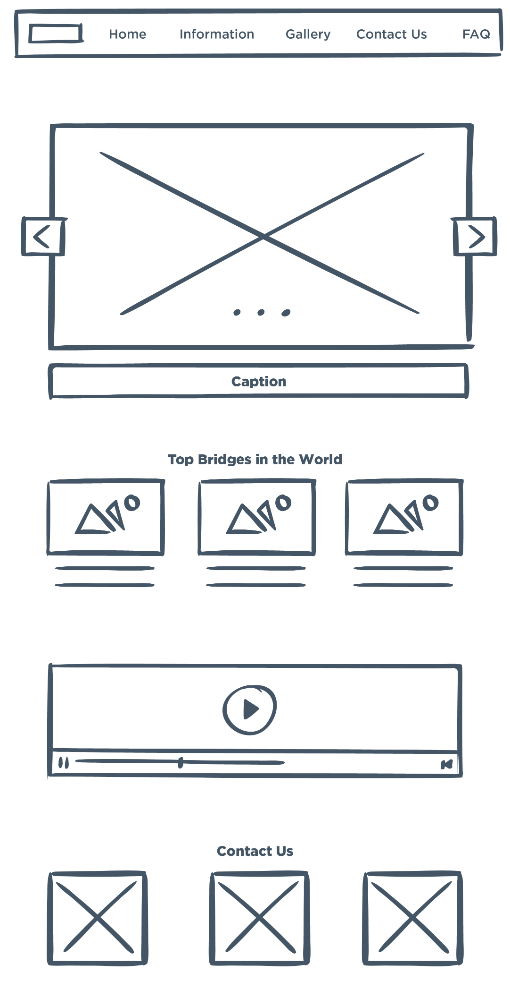**Mock of the website:**

**1) Homepage:**

**2)Top Highest, Top Longest, Top Oldest, World Famous pages:**

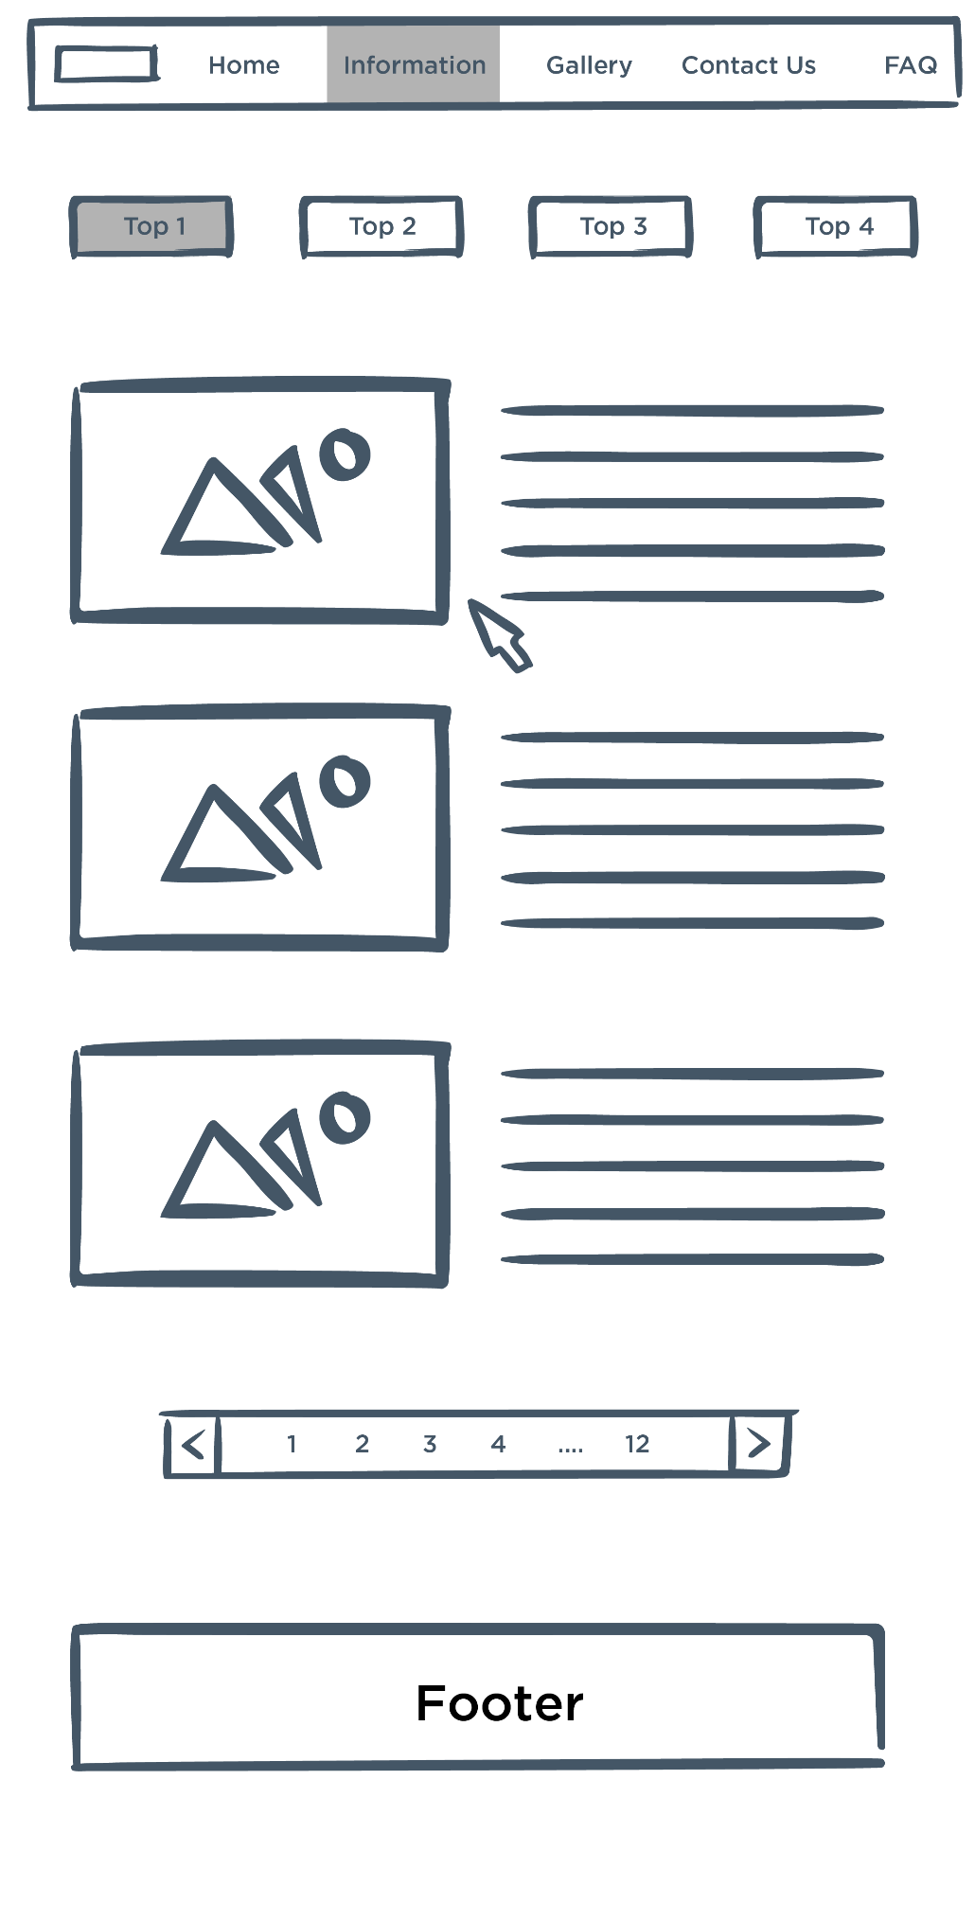

**3)Detail pages:**

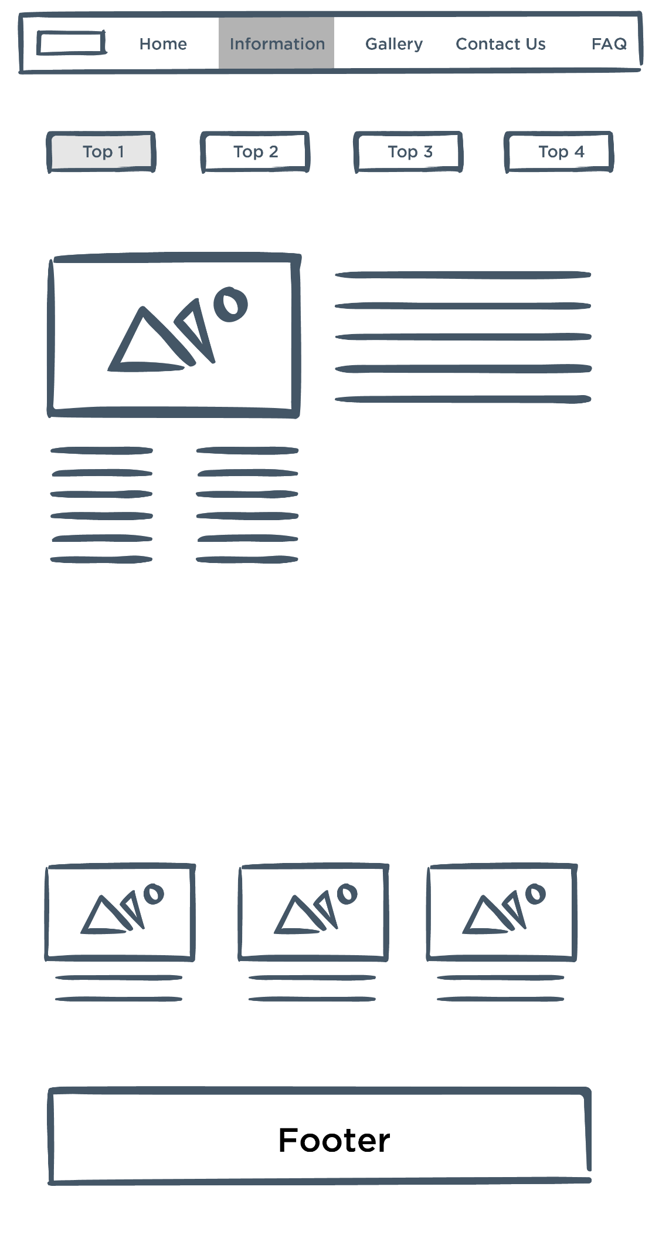

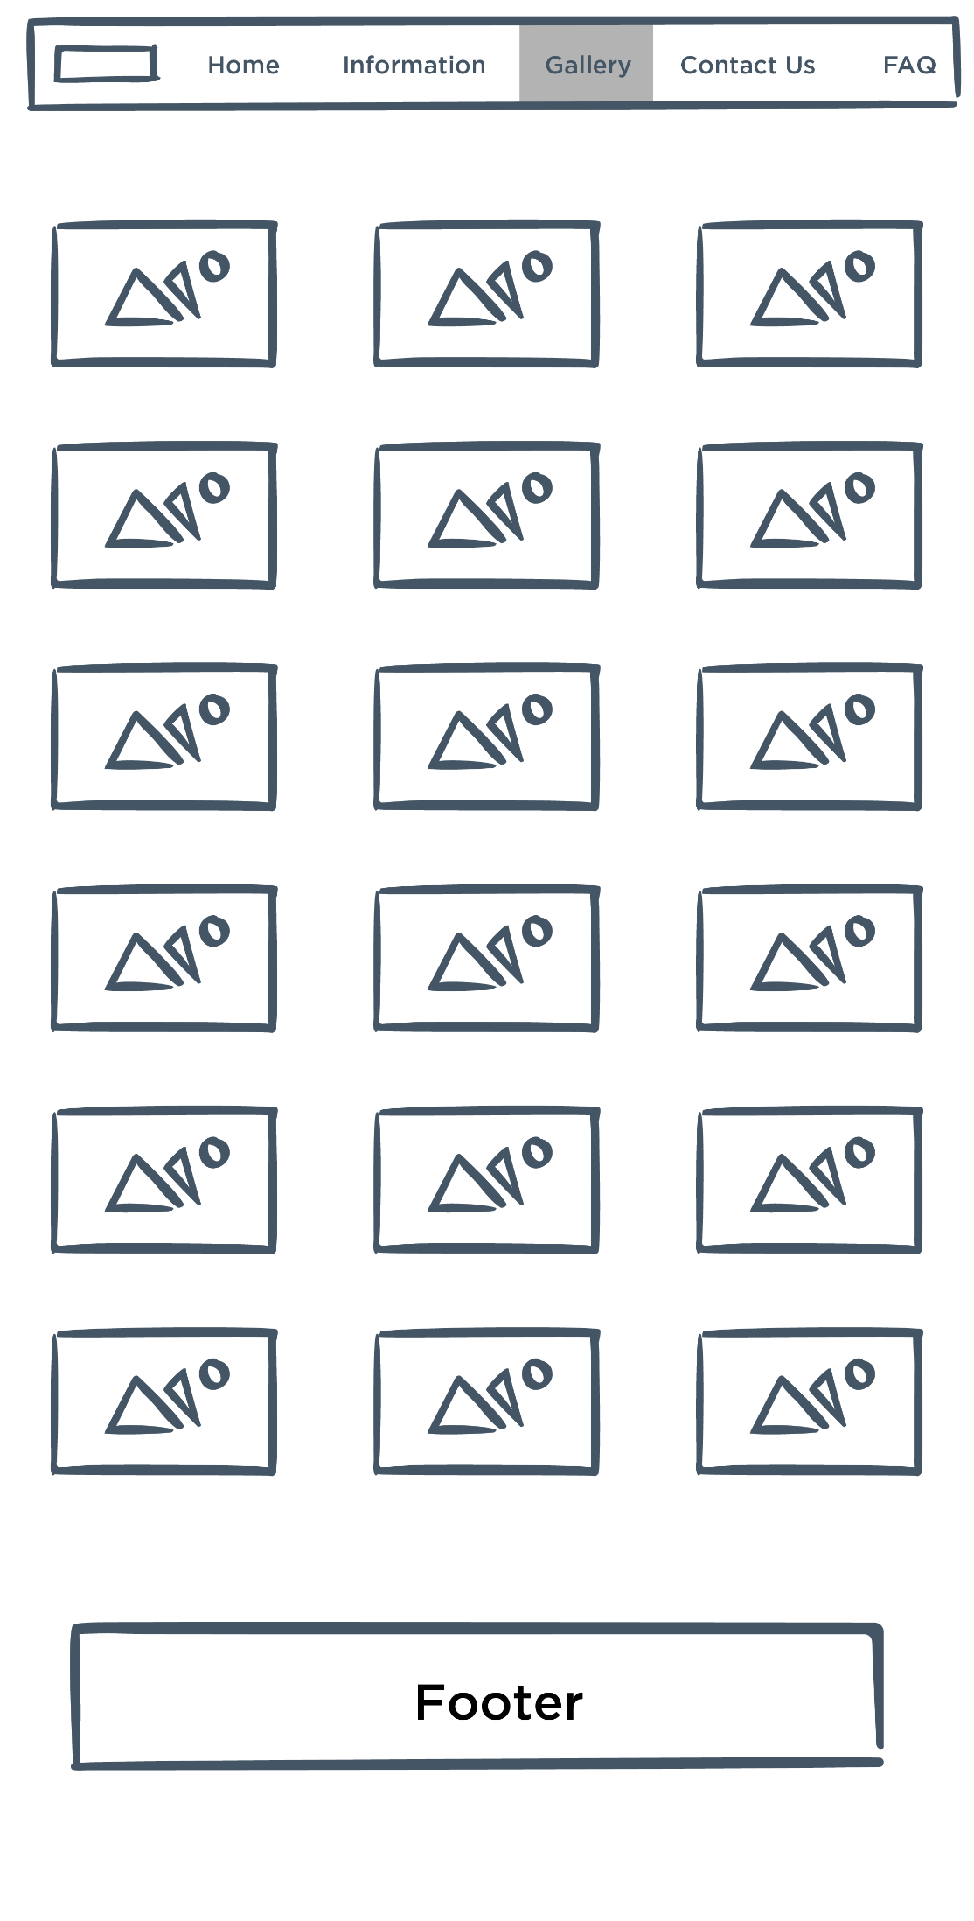

**4)Gallery pages:**

**4)Contact page:**

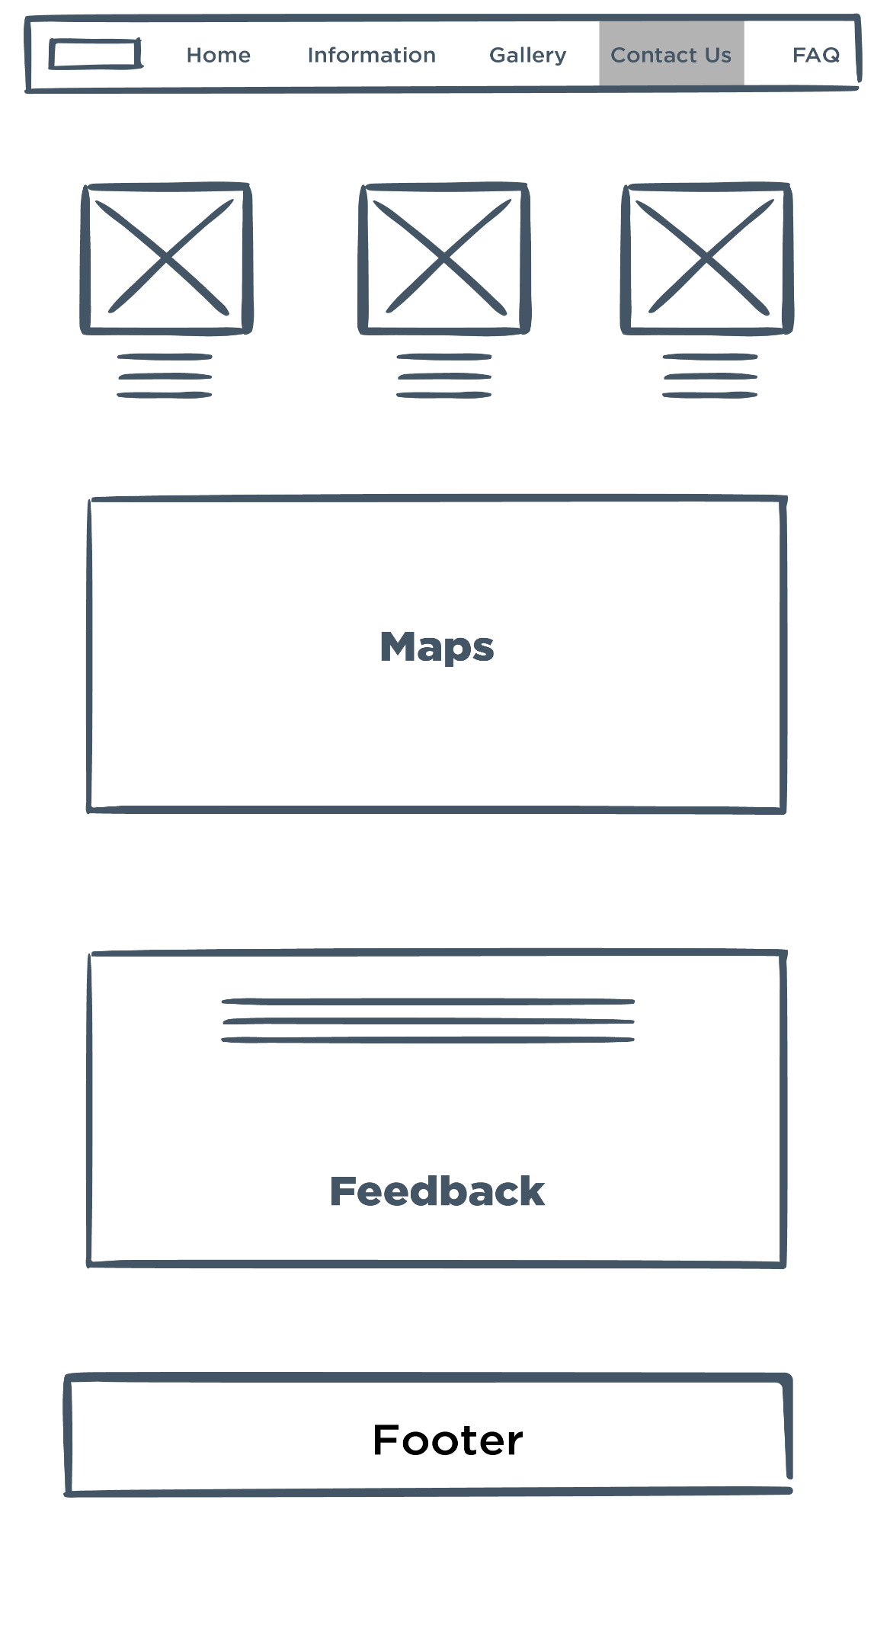

**5)Feedback Page:**

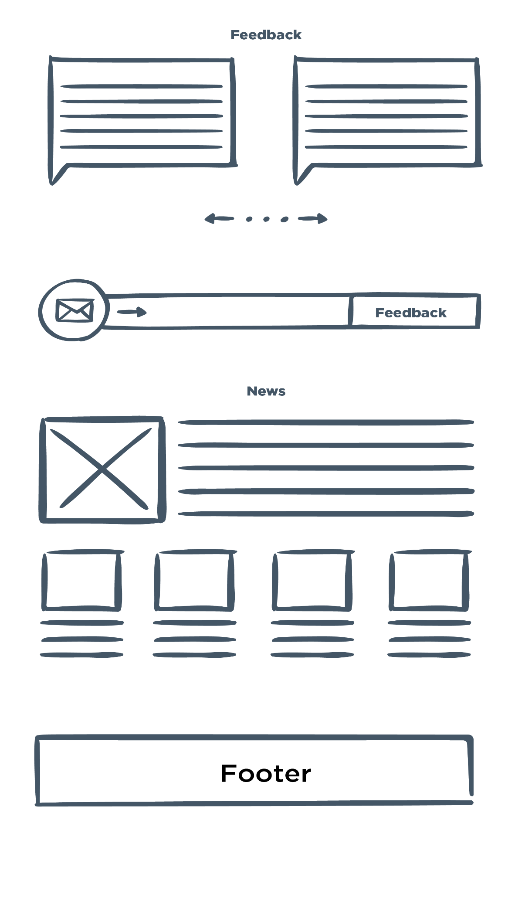

**TASK SHEET REVIEW 2**

|  |  |  |  |  |
| --- | --- | --- | --- | --- |
| **No.** | **Description** | **Begin Date** | **TeamMate Name** | **Notes** |
| 1 | Mock of the website | 29/5/2023 | Loc |  |
| 2 | Site map | Nhat |  |
| 3 | Task sheet | Khoa |  |

|  |  |
| --- | --- |
| **Date:** | |
| Signature of Instructor:  **Le Mong Thuy** | Signature of Team Leader:  **Nguyen Huu Minh** |

# 

# WEBSITE DESCRIPTION

- **Homepage** displays a few top famous bridges with short description about their features. Some advertisements will all so be shown on this page.

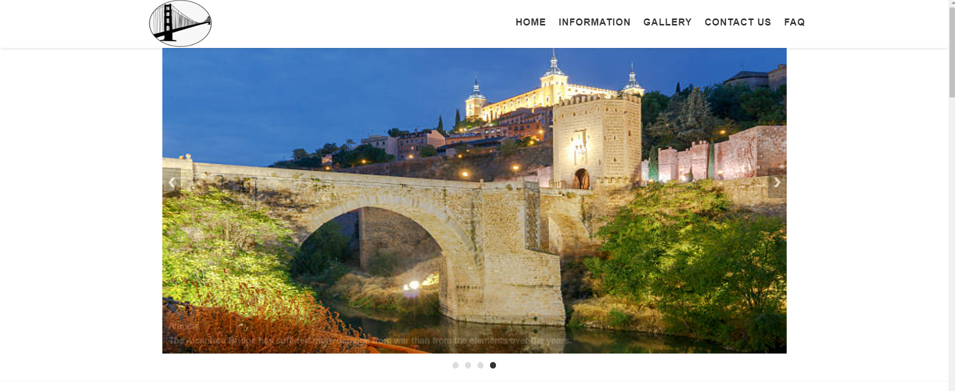

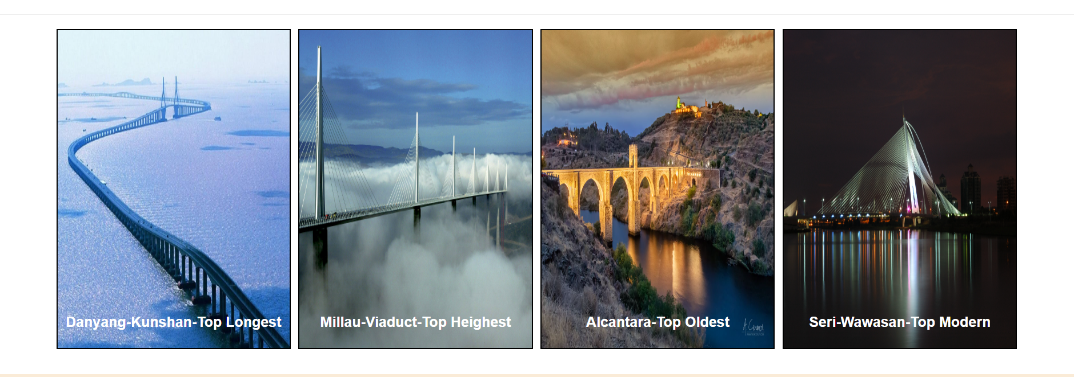

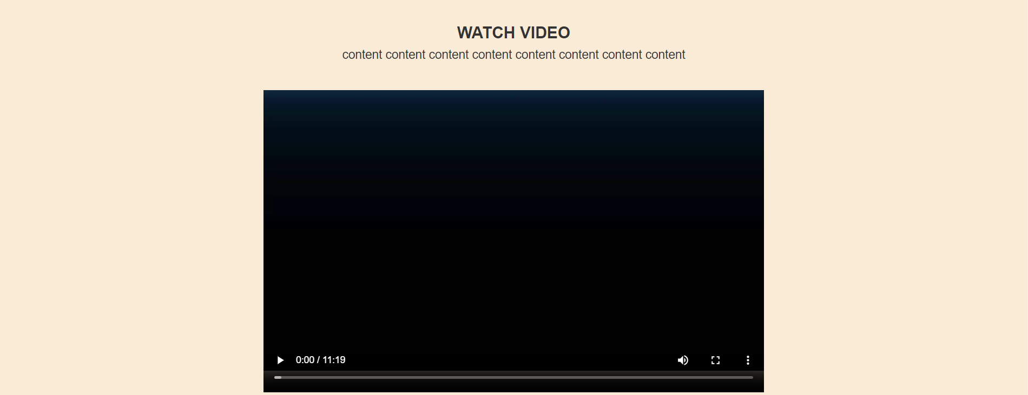

- **Top Longest page** presents short briefs of top longest bridgest around the world. If users want to have more information about a particular bridge, they can click on the image next to the description paragraph. It will then open up a detail page about that bridge.

- **Top Highest page** shows short briefs of top highest bridgest around the world. If users want to have more information about a particular bridge, they can click on the image next to the description paragraph. It will then open up a detail page about that bridge.

- **Top Oldest page** provides short briefs of top oldest bridgest around the world. If users want to have more information about a particular bridge, they can click on the image next to the description paragraph. It will then open up a detail page about that bridge.

- **Modern famous page** includes short briefs of world famous bridges.

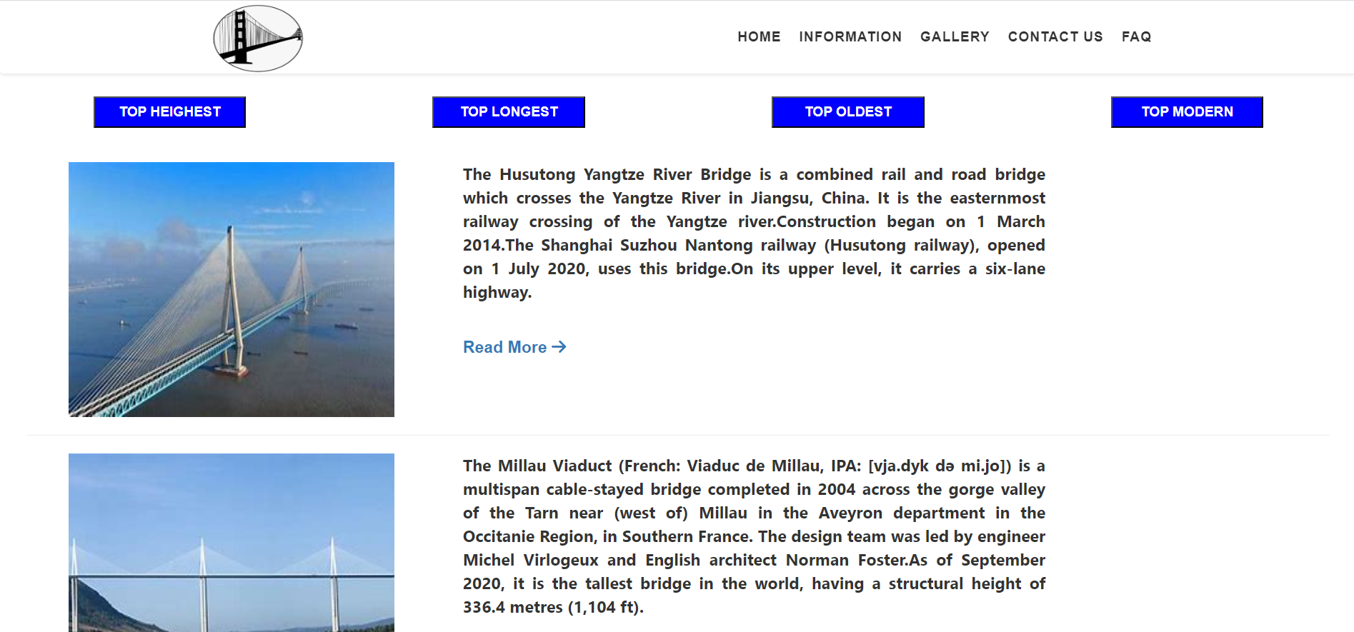



- **Detail page** displays full description of a specific bridge. More images of that bridge will be presented in the gallery. In addition, there is comment section which visitors can give feedback to AmazingBridges.com for improving purpose; they can also find usefull information which may help them get to the place.

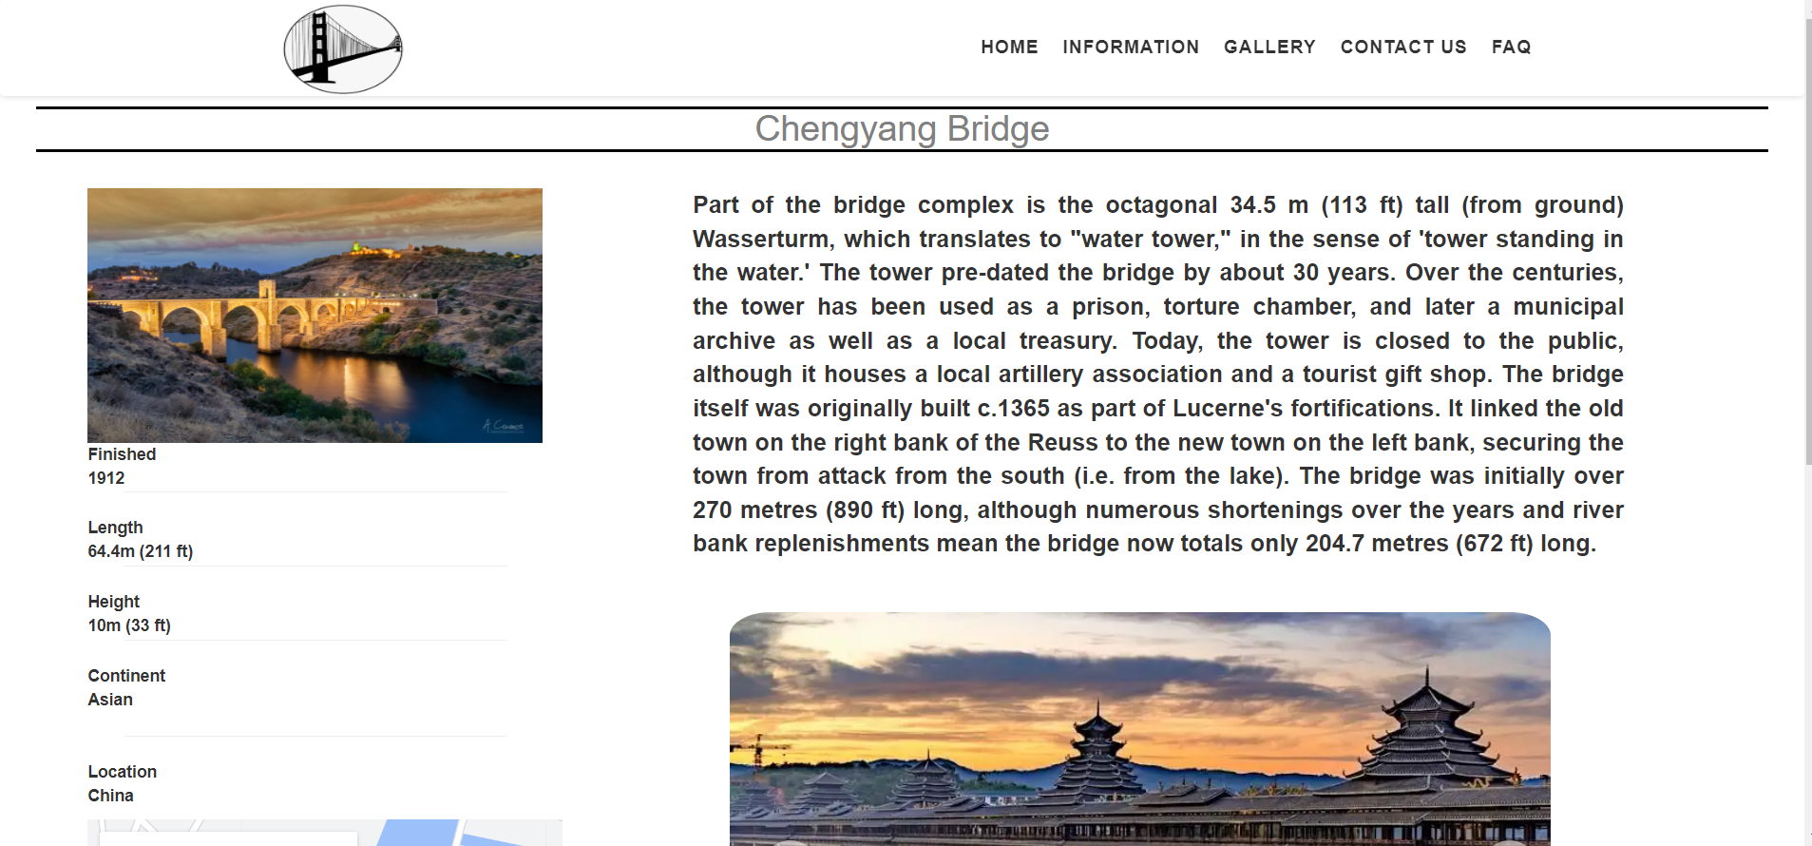



- **Gallery:** display beautiful bridges.

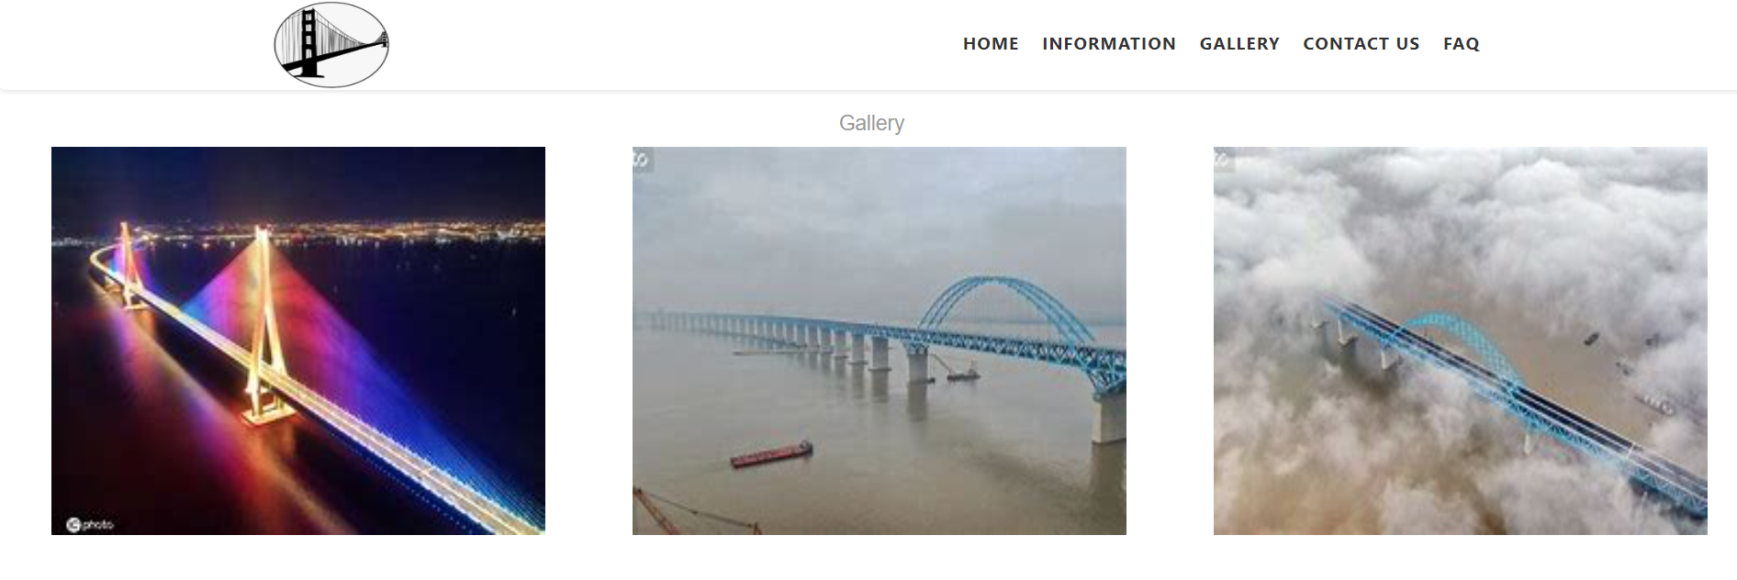

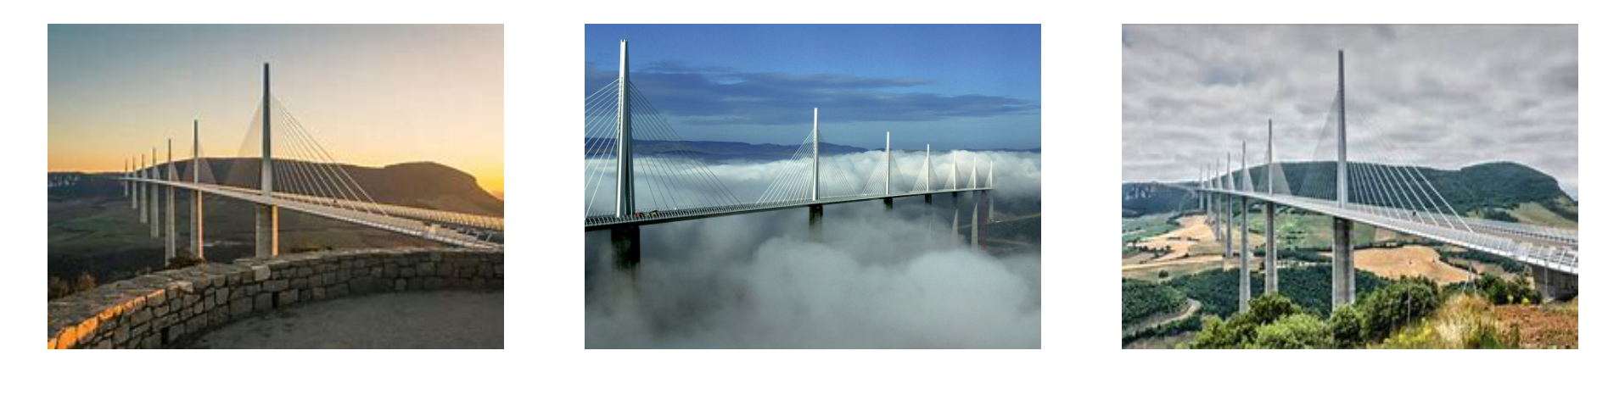



- **Contact** : Visitors can get in touch with AmazingBridges.com via email or phone number on the page.

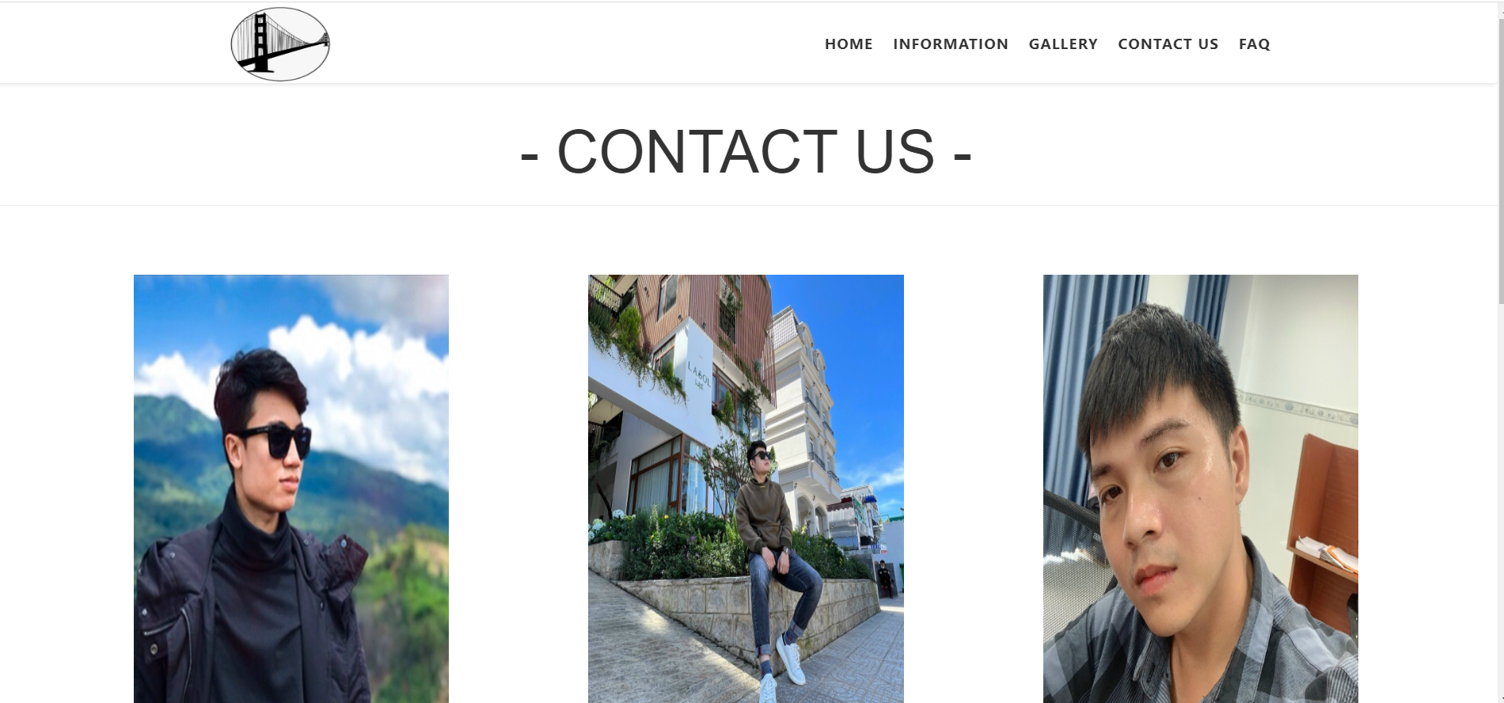





**JAVASCRIPT DESCRIPTION**

Slide transition image.

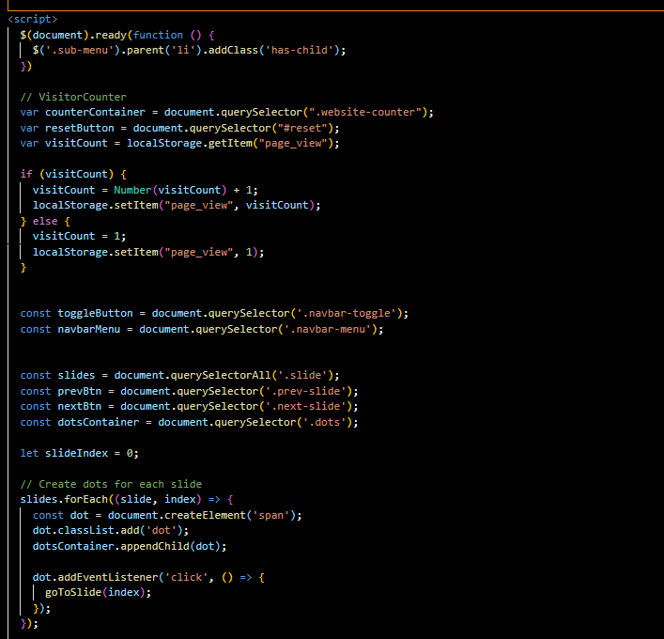

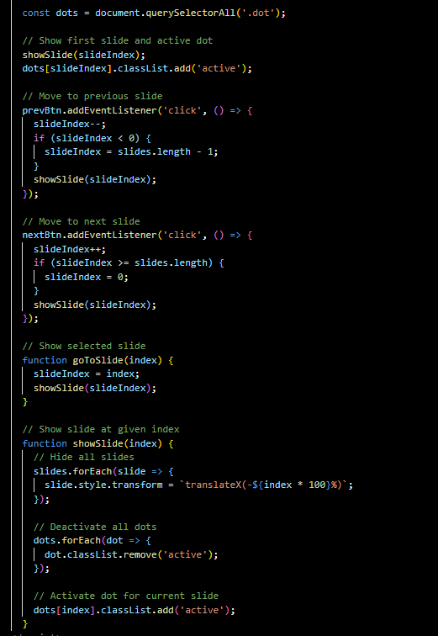

**TASK SHEET REVIEW 3**

|  |  |  |  |  |
| --- | --- | --- | --- | --- |
| **No** | **Page Name** | **Begin Date** | **TeamMate Name** | **Notes** |
| 01 | Homepage | 6/3/2023 | Loc | Completed |
| 02 | Top Longest | 6/3/2023 | Khoa | Completed |
| 03 | Top Highest | 6/3/2023 | Khoa | Completed |
| 04 | Top Oldest | 6/3/2023 | Nhat | Completed |
| 05 | Modern Famous | 6/3/2023 | Nhat | Completed |
| 06 | Detail pages | 6/3/2023 | Loc | Completed |
| 07 | Contact pages | 6/3/2023 | Khoa | Completed |

|  |  |
| --- | --- |
| **Date:** | |
| Signature of Instructor:  **Le Mong Thuy** | Signature of Team Leader:  **Tran Ngoc Bao Khoa** |